THE HOLLY HILL INN
Food served Monday – Saturday
12pm – 8pm

Starters

Soup of the day-£4.95
Served with toasted malted bread (v) (gf when served with gf bread)

Potato skins -£4.50 (v)
Deep fried potato skins with garlic dip

Chicken wings - £5.95
Served with BBQ dip

Southern fried chicken goujons - £5.95
Served with BBQ dip

Halloumi fries - £5.95
Served with sweet chilli dip

Hot and spicy chicken wings - £5.95
Served with bbq dip

Sharers

Nachos - £7.95
Topped with cheese, guacamole, soured cream & salsa.
Add homemade chilli £3.50

Loaded skins - £8.95
Deep fried potato skins, topped with crispy bacon, melted cheese & drizzled with garlic mayo & BBQ sauce.

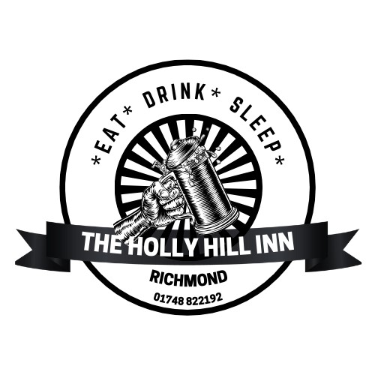

Sandwiches - served on white or malted bread.
(gluten free bread available)

All served with homemade coleslaw, salad and chips.

Cheddar cheese and red onion - £7.95 (v) (ve when served with vegan cheese)

Cheddar cheese and tomato - £7.95 (v) (ve when served with vegan cheese)

Tuna mayo - £7.95

Chicken & bacon mayo - £7.95

Brie and bacon - £7.95 (v when served without bacon)

Ham Salad - £7.95

Main courses

Hunters chicken - £13.95 (gf)
Breast of chicken covered in barbeque sauce and topped with bacon and melted cheese served with chips and salad.

Scampi and Chips - £13.95
Served with garden or mushy peas

Steak and ale casserole with a pastry top - £14.95
Served with homemade chips and vegetables

Homemade Lasagne - £13.95
Served with homemade chips and salad

Gammon - £14.95 (gf)
Served with homemade chips, garden peas and egg or pineapple

Homemade chilli - £12.95 (gf)
Served with chips or rice and a side of nachos

Classic Cheese Burger - £13.95
2 x 4oz burger topped with cheese in a bread bun with lettuce, and a pot of burger sauce
Served with fries and coleslaw
Add bacon £1.00
Add homemade chilli £3.50

Vegan chilli - £12.95 (v)(ve)(gf)
Served with chips or rice and a side of nachos

Ham, egg and chips £10.95
Served with garden peas

Sides
Chips - £2.95
Fries - £3.25
Sweet potato fries -£3.95
Side of vegetables - £2.95
Side salad - £2.95
Portion of homemade coleslaw - £1.45
Peppercorn sauce £2.45 (gf)
Desserts - £5.95

Apple and Blackberry crumble

Jam sponge

Selection of cakes and cheesecake in our cake fridge in the restaurant

All served with cream, ice cream or custard

Allergy Notice:If you require any information regarding allergies please speak to a member of staff

