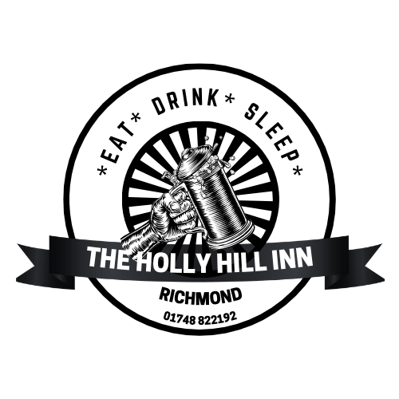

***Sunday Lunch at The Holly Hill***

***Served 12pm-4pm***

**Starters**

**Prawn Cocktail -£6.95**

Served with toasted malted bread (gf when served with gluten free bread)

**Soup of the day-£4.95**

Served with malted bread (v)(ve)(gf when served with gluten free bread)

**Potato skins -£4.50**

Deep fried potato skins with garlic dip (v)

**Allergy Notice**:If you require any information regarding allergies please speak to a member of staff

**Main courses**

**Roast chicken breast**

**Topside of beef**

**Roast pork**

(gf when served without yorkshire pudding and with gf gravy)

**£12.95** (Small **£9.95**)

Children's **£6.95 (recommended for under 5’s)**

Sausage/veggie sausage also available for children

**Vegetarian Option £12.95**

(please ask a member of staff for today's options)

Served with roast potatoes, mash, carrots and broccoli, a yorkshire pudding and a jug of gravy.

**Looking for a light lunch**….. Choose from white or malted brown bread

pork & apple sandwich

beef & gravy sandwich

brie (v)

served with roast potatoes and a jug of gravy **£8.95**

(gf bread and gravy available)

**Ask a member of staff to see our dessert board**